CPT-202 ASSIGNMENT – 6 SQL
- USE KimTay Pet Supplies DATABASE
- Each question is worth 10 points.
- Answer each of the following questions after reading/reviewing Chapter 6 of your textbook.
- Each question requires you to write SQL Code. Submit your SQL Code. You may submit your Output/Results too, but it is NOT necessary for this assignment as there are no SELECT statements to be written.
- Submit your answers in a Word document via the Assignments link in D2L.

- Submit the SQL Code that will do the following: Create a NONCAT table. Name the table NONCAT_<YourStudentID> (or NONCAT_DonaldDuck, NONCAT_MickeyMouse, etc.) with the structure shown in Figure 6-28.
create table NONCAT_042854
(
ITEM_ID CHAR(4) PRIMARY KEY,
DESCRIPTION CHAR(30),
ON_HAND DECIMAL(4,0),
CATEGORY CHAR(3),
PRICE DECIMAL(6,2)
)
- Submit the SQL Code that will do the following: Insert into the NONCAT table the item ID, description, number of units on hand, category, and unit price from the ITEM table for each item that is not in category CAT.
INSERT INTO NONCAT_042854
SELECT ITEM_ID, DESCRIPTION, ON_HAND, CATEGORY, PRICE
FROM ITEM
WHERE CATEGORY != 'CAT';
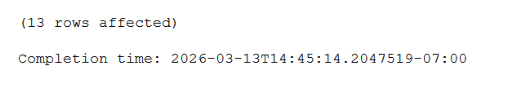

- Submit the SQL Code that will do the following: In the NONCAT table, change the description of item ID DT12 to “Dog Toy Gift Bonanza.”
UPDATE NONCAT_042854
SET DESCRIPTION = 'Dog Toy Gift Bonanza'
where item_id = 'DT12'
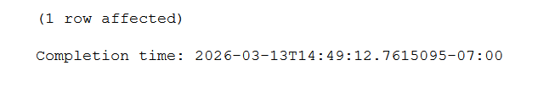
- Submit the SQL Code that will do the following: In the NONCAT table, increase the price of each item in category BRD by five percent. (Hint: Multiply each price by 1.05.)
UPDATE NONCAT_042854
SET PRICE = PRICE * 1.05
where CATEGORY = 'BRD'
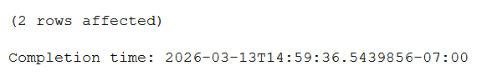
- Submit the SQL Code that will do the following: Add the following item to the NONCAT table: item ID: FF17; description: Premium Fish Food; number of units on hand: 10; category: FSH; and price: 11.95.
insert into noncat_042854
values ('FF17', 'Premium Fish Food', 10, 'FSH', 11.95)
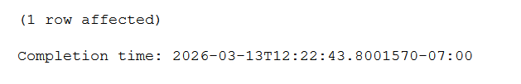

- Submit the SQL Code that will do the following: Delete every item in the NONCAT table for which the category is HOR.
delete from noncat_042854
where category = 'HOR'
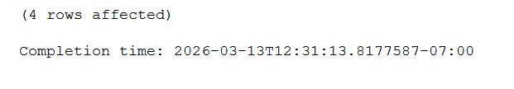
- Submit the SQL Code that will do the following: In the NONCAT table, change the category for item UF39 to null.
update noncat_042854
set category = null
where item_id = 'UF39'
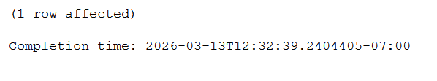
- Submit the SQL Code that will do the following: Add a column named ON_HAND_VALUE to the NONCAT table. The on-hand value is a seven-digit number with two decimal places that represents the product of the number of units on hand and the price. Then set all values of ON_HAND_VALUE to ON_HAND * PRICE.
alter table noncat_042854
add on_hand_value decimal(7,2);
update noncat_042854
set on_hand_value = on_hand * price;
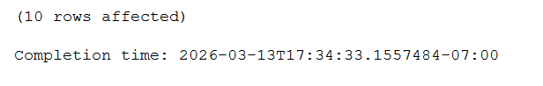

- Submit the SQL Code that will do the following: In the NONCAT table, increase the length of the DESCRIPTION column to 40 characters.
alter table noncat_042854
alter column description varchar(40);
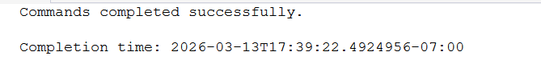
- Submit the SQL Code that will do the following: Remove the NONCAT table from the KimTay Pet Supplies database.
drop table noncat_042854
